CSE 3055 DATABASE SYSTEMS PROJECT STEP 2

----------------------------------------

REQUIREMENT ANALYSIS&CONCEPTUAL DATABASE DESIGN

Instructor: Mustafa Ağaoğlu

Group Representative: Barış Giray Akman-150121822

Group Members

Mert Muslu- 150120027

Gülsüm Ece GÜNAY- 150121539

Erkut DÖNMEZ- 150120051

-1-

**TABLE OF CONTENTS**

1. Entities and Definitions
2. Business Processes & Definitions

1. Functional&Non-Functional Requirements
2. Business Rules & Constraints
3. EER Diagram
4. Customer Info & Document

-2-

**1. Entities & Definitions**

**Customer:** The customer entity will include necessary details of the customer for the system. Attributes of the customer are uniquely customer ID, customer name and surname, customer address, customer budget, and customer contact number.

**Service:** The service entity will include details related to the service that company will provide. Attributes of the service are service ID, service name, service description, and service price.

**Product:** The product entity will hold the details of the products that will be sold by the company. Attributes of the product are product ID, product name, product description, and product price.

**Appointment:** The appointment entity will cover the details of the appointment the customer will arrange through the system. Attributes of the appointment are appointment ID, appointment date, and appointment hour.

**Order:** It’s an entity that will determine the order request of the customers. It includes the necessary the details of the order arranged by the customer.

**Employee(abstract):** Employee entity includes the details of the people working in the company. It holds a unique employee ID, the employee's first name and last name, information about hired date, and the employee’s address.

**Salesperson:** The salesperson entity captures the information related to people who holds sales roles. Each salesperson has an expected sales rating and how many products sold

**Beauty Care Specialist:** The beauty care specialist entity holds the necessary information about the specialist that will deliver the service for the customers.

**Warehouse:** Warehouse entity is an entity that will store the whole products in the stock.

**Department:** Department entity includes the details of the departments of the company. Attributes of the department are department ID, department name

**Certificate:** It implies the certification of the beauty care specialist.

-3-

**2. Business Processes & Definitions**

-Products are entered to the warehouse by the owner of the company.

-Sales person will be able to review and list the orders she checks.

**Process for the Order**

-Customers enter the system and orders any product he/she demands.

-System checks whether the budget of the customer is sufficient for the product. If not, order request will be rejected.

-In the case of order completed, product will be inserted to the different record table within it’s entire attributes.

-If product is sold out, it wont’ be displayed through the system for the customer.

**Process for the Appointment**

-Customer enters the system and choose one of the appointments through the system for the available dates/hours defined previously.

-Initial step is checking the budget of the customers to determine if he/she may afford the service. If budget is insufficient, appointment adjustment will fail.

-In the case of section is appropriate for the customer and budget is sufficient, it will be assigned to him/her.

**3. Functional/ Non-Functional Requirements**

**Functional Requirements**

* The system must provide a comprehensive catalog of beauty applications, personal care services, and products.
* Services and products must be searchable and categorized for easy access.
* The system must allow customers to register, providing their name, age, and contact information.
* Customers must have the ability to schedule beauty applications for the specific specialists.
* Customers must be able to update their information (e.g., address, preferences) through the system.

-4-

**Non-functional Requirements**

* There must be a user-friendly interface to simplifying the usage of the application.
* The system should be designed to support future updates or modifications to meet changing regulatory requirements.
* The system should comply with data protection regulations
* SQL Server must be used as a database server.
* Customers who can’t meet the service price the mustn’t be able to utilize it.
* Customers who have insufficient budget for the product mustn’t be able to buy it.
* Customer must provide their address to order any product.

**4. Business Rules & Constraints**

* Each employee can be either a salesperson or a beauty care specialist.
* Each employee has exactly one manager and a manager can manage multiple employees.
* Each employee works for exactly one department and each department has one or more employees who work for that department.
* Each beauty care specialist delivers one or more services according to the appointments which are given by the customer.
* Each appointment is provided by one service.
* Each customer sets more than one appointment and each appointment is assigned to exactly one customer.
* Each customer sets zero or more appointment, and an appointment is set by only one customer.
* Each sales person may check more than one order. Each order has to be checked by exactly one salesperson.
* Each order should be requested by only one customer, and each customer may request at least zero or more order.
* Each order contains only one product, and each product may be included by more than zero or more order.
* Each product is stored in only one warehouse, and the warehouse may store multiple products.

-5-

**5. EER DIAGRAM**

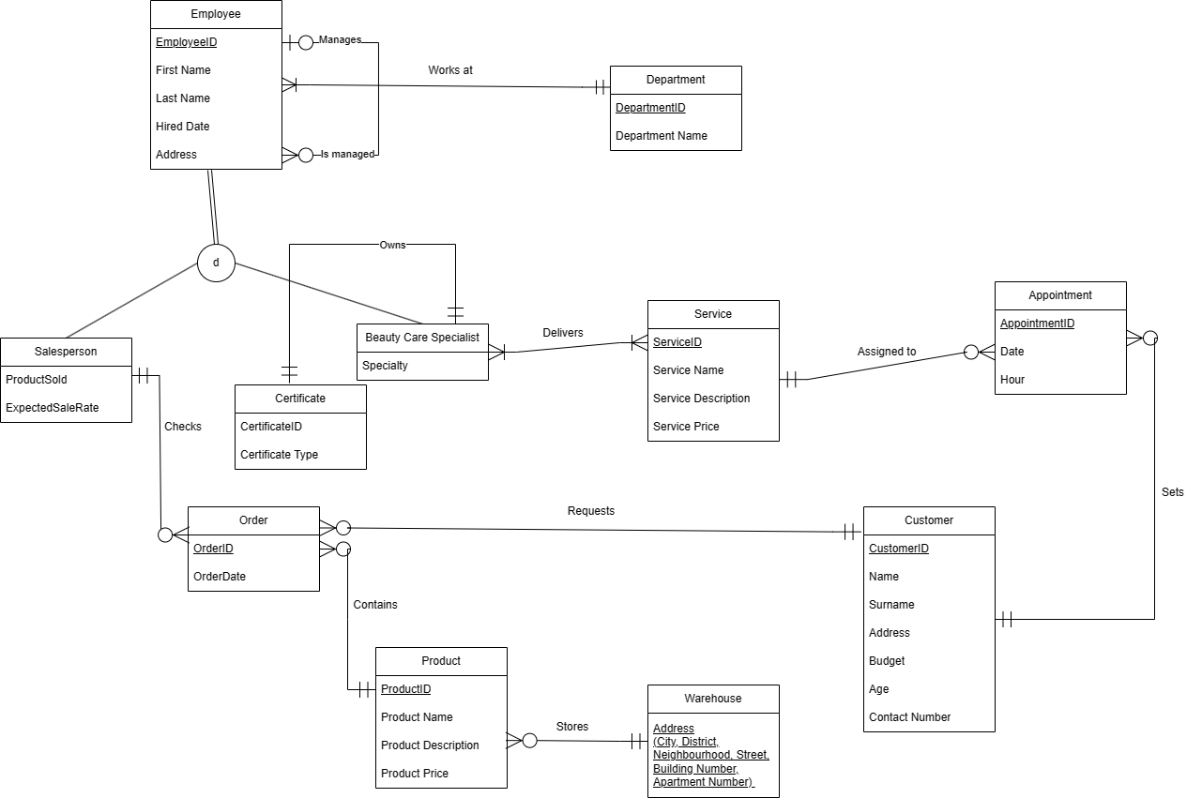

-6-

**6. CUSTOMER INFO&DOCUMENT**

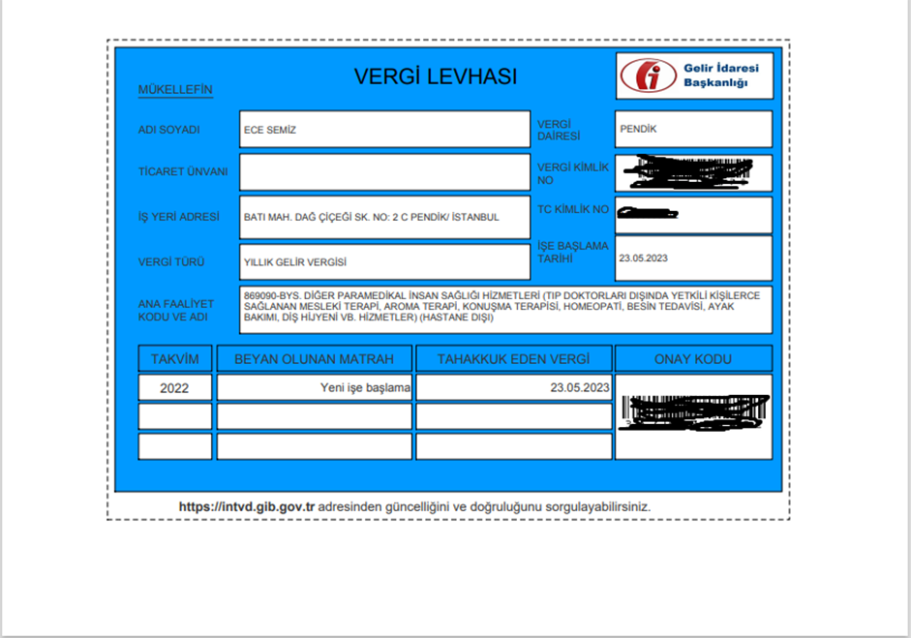

-7-